REPLACEMENT PARTS FOR McCAREY

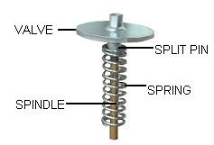

REPLACEMENT PARTS FOR McCAREY

 | O.D. | I.D. | HT.
McCarey New Rubber 100mm (4") | 234 | 100 | 6 | MR100 | $22.43
McCarey Split Pin |  |  |  | VE21 | $3.51
McCarey Brass Spindle |  |  |  | MBS | $28.38
McCarey Spring |  |  |  | MS | $20.04
McCarey Bend Rubber 80mm (3") | 102 | 77 | 10 | MHBR80 | $6.42
McCarey Bend Rubber 100mm (4") | 127 | 101 | 12 | MHBR100 | $16.64
McCarey Bend Rubber 125mm (5") | 149 | 124 | 9 | MHBR125 | $11.26

